Milestone #3: Outland Adventures Case Study

Silver Team:

Shayla Bradley, Patrick Ellis, Yawa Hallo, Abigail Klein

December 11, 2022

**Reports**

1. Do enough customers buy equipment to keep equipment sales?

We joined the customer, equipment and customer_order table to create a table that prints the equipment each customer bought and rented from Outland Adventures. A count function is used to calculate the total amount of rentals and total amount of sales. Then the profits are calculated to show Blythe and Jim how much more profit they make off of equipment sales.

**Result**

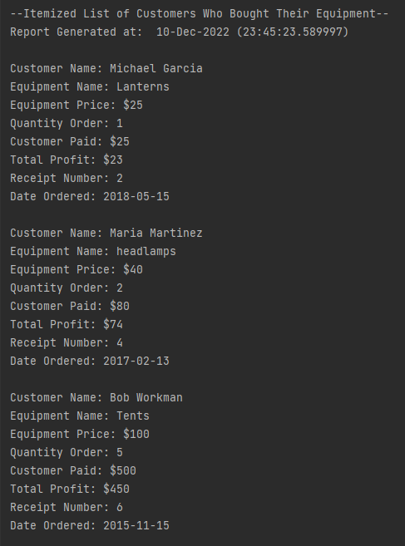

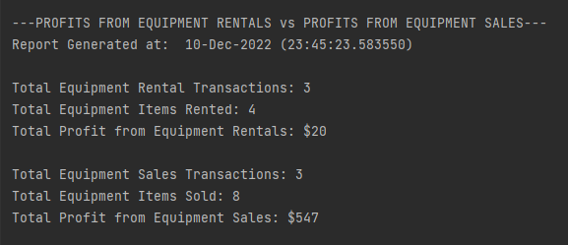

2. So far, they have conducted treks in Africa, Asia, and Southern Europe. Is there anyone of those locations that has a downward trend in bookings?

The report displays all bookings by location and a count function is used to calculate the total number of bookings by location. With these results Blythe and Jim can see the trend in bookings by each location.

**Result**

3. They are a little concerned about the age of some of the inventory. Are there inventory items that are over five years old?

By joining the equipment and supply_order table we created a table displaying equipment with an order date of over 5 years old. The results show which equipment is out of date, so they can see how much equipment needs to be replaced.

**Result**

**Finalized ERD**

